B. MULTI-NUTRIENTS NPK FERTILIZERS
To keep pace with the trend in use of fertilizers, in recent years, the company has coordinated with famous scientists in Agriculture, to create Vandien fertilizers that are suitable for each kind of tree, on each soil type in each period and plant growth. It is convenient to farmers without much effort but still bring high economic efficiency and right compliance to the principles of the use of fertilizers (balanced, adequate, timely, correct way). Vandien fertilizers also improve the environmental field, as well as protect our own health.
Multi-nutrient NPK fertilizers are produced base on physiological characteristics of each type of tree in each period; on each regional soil. We have different recipes of larg- propotion nutrients (N, P₂0₅, K₂0), medium- propotion nutrients (S, Ca0, Si0₂, Mg0) and micro-nutrients (Fe, B, Mn, Zn, Co, Cu, Mo…) that supply plant all nutrients timely. By making from FMP, multi-nutrient NPK fertilizers has all advantages of FMP and specially suit to exhausted soil, acid soil, and saline soil. Using Vandien fertilizers can reduce saline, aluminium, and moss without using lime.
VAFCO has more than 40 multi-nutrient NPK fertilizers specialized for each type of tree, on each soil and in each period, including some sort of key as follows:
- Multi-nutrient NPK 6.11.3 ; 6.12.3 specialized for rice in basal fertilization.
- Multi-nutrient NPK 16.5.17 specialized for rice in top dressing fertilization.
- Multi-nutrient NPK 4.9.5 specialized for corn in basal fertilization.
- Multi-nutrient NPK 14.8.7 specialized for corn in top dressing fertilization
- Multi-nutrient NPK 8.8.8, 9.9.12 specialized for potato in basal fertilization.
- Multi-nutrient NPK 22.5.11, 12.6.10 specialized for potato in top dressing fertilization
- Multi-nutrient NPK 5.10.6 for manioc
- Multi-nutrient NPK 4.12.7 for beans, peanuts
- Multi-nutrient NPK 4.10.4 specialized for fruit tree in top dressing fertilization
- Multi-nutrient NPK 6.12.5 specialized for sugar cane, pineapple in basal fertilization.
- Multi-nutrient NPK 15.5.20 specialized for sugar cane, pineapple in top dressing fertilization
- Multi-nutrient NPK 10.5.12; 10.8.12 for coffee
- Multi-nutrient NPK 16.8.8; 16.8.4; 3.0,5.1, 8.6.4; 22.5.11; 25.5.11; 2.1.2; 4.1.2+5%S; 4.1,5.4 applied to tea.
- Multi-nutrient NPK 10.5.12; 10.8.12 for mulberry: including 4 recipes
+ Recipe 1 for mulberry on hill land: 18%N-5,6% P₂0₅ – 9% K₂0.
+ Recipe 1 for mulberry on field: 17%N-7,5% P₂0₅ – 5,5% K₂0.
+ Recipe 1 for seed mulberry: 16,6%N-7,3% P₂0₅ – 6% K₂0.
+ Recipe 1 for mulberry on saline land: 18%N-8% P₂0₅ – 3% K₂0.
- Multi-nutrient NPK for variety of plant such as 5.10.3; 5.12.3; 10.10.5; 10.12.5; 12.8.12; 16.616; 16.16.8; 12.12.12; 20.3.20…
IV. INTRODUCTION SOME MAJOR PRODUCTS AND USAGE
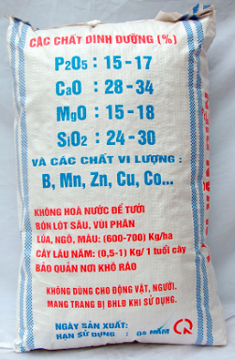
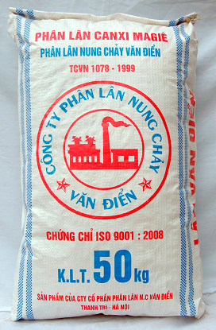
1. Vandien fused magnesium phosphate fertilizer.
- Product Name: Vandien FMP
- Composition: P2O5 = 15-17%, CaO = 28-34%, MgO = 15-18%, SiO2 = 24 to 30% and other micronutrients such as B, Mn, Zn, Cu, Co ...
- Instruction:
For rice:
It is best for basal fertilization. Apply 400-600kg/ha of FMP with organic fertilize pre-plant spread or with incorporation at last cultivation before planting. The dosage depends on rice variety. For high-yield rice variety, the dosage is 700kg/ha.
For coffee and rubber tree (in basic construction period)
- For coffee tree:
Situation | Rates | Comments
New plantation: basal fertilization | 1,0-1,5kg/hole | Mix Vandien FMP with organic fertilizer with the soil and back filling about 20 days before planting.
Second year: apply at the beginning of rain season | 500-600gg/ha | Digging a trench (10-15cm wide, 5 cm deep) around and 20-30cm from the foot of the tree. Filling the mixture of FMP, urea and potash in the trench then backfilling with soil. For hill land with slope more than 15⁰, filling the mixture in nutrients-keeping hole system then backfilling.
Third year: apply at the beginning of rain season | 500-600kg/ha

- For rubber tree:
Situation | Rates | Comments
New plantation: basal fertilization | 0,3-0,5kg/hole | Mix Vandien FMP with organic fertilizer with the soil and back fill about 5 days before planting.
Second year: apply at the beginning of rain season | 350-400gg/ha | Spread the mixture of FMP, urea and potash on the band 1-1,5m wide between two row of trees then backfilling with soil. For hill land with slope more than 15⁰, filling the mixture in nutrients-keeping hole system then back filling.
Third year: apply at the beginning of rain season | 500-600kg/ha

c. For other perennial crops: Tea, oranges, tangerines, longan etc ground fertilization dosage is recommended at 1-1.5 kg/tree in first days of planting or after start of new growth. Dosage per year of growth: 0.5 kg/year. Note to balance fertilizer nitrogen, phosphorus and potassium. Digging a trench around the tree root (by the leaf canopy). Filling the mixture of FMP, urea and potash in the trench then back filling with soil. Incorporate with irrigation / rainfall.
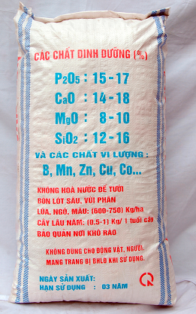
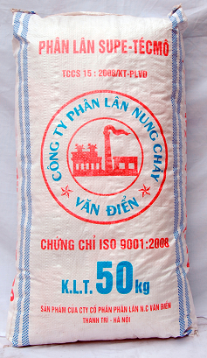
2. Super thermo Phosphate Fertilizer:
- Product Name: Super thermo Phosphate Fertilizer.
- Usage: Super thermo Phosphate Fertilizer is blended with Fused Magnesium Phosphate Fertilizer to make full advantages of these two types of fertilizers. Water-soluble super phosphate fertilizer can be used in initial period of growth and slow-absorbtion FMP fertilizer is used for fruit development or ripening stage, and also for soil improvement. This fertilizer suits to soil with high pH level.
- Comment: This blended fertilizer can be applied like in the case of Van Dien FMP fertilizer.
3.. Multi-nutrients NPK of special use to Rice (2 categories): NPK 6.11.2 & 16.5.17
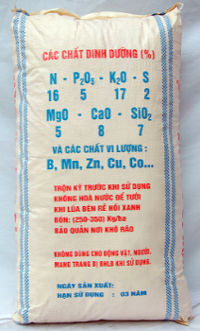
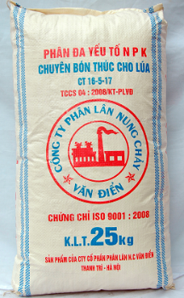
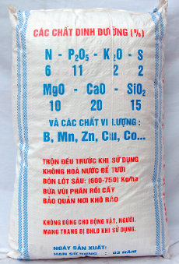
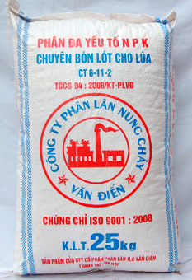

Category | N | P₂O₅ | K₂O | S | MgO | CaO | SiO₂ | Microelement (%)
NPK 6-11-2 | 6 | 11 | 2 | 2 | 10 | 20 | 15 | Zn, B, Cu, Co, Mn ...
NPK 16-5-17 | 16 | 5 | 17 | 1 | 5 | 8 | 7

Dosage recommendable for rice:
a. Deep-line basal fertilization: using multi- nutrient NPK 6.11.2
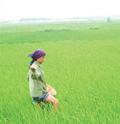
+ Apply 20-25kg/ sao (Vietnamese unit, that equals 360m²) depent on each soil type and rice variety.
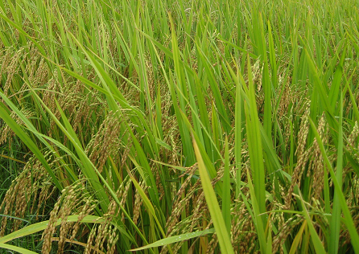
+ Comment: - For transplanted rice: Apply pre-plant spread or with incorporation at last cultivation before planting, along with organic fertilizer, and back filling, then settled the land, draining off limpid water before implantation. Where the fields with high water level and edges that the water does not flow, we can normally applied. Avoiding loss of muddy water.
- For spread seeding:Apply incorporation with organic fertilizer at last cultivation. Adding 2-3 kg/sao if without organic fertilizer.
b, Soon top dressing: using multi- nutrient NPK 16-5-17.
+Rate: Apply from 10 to 13 kg / sao, depending on season, variety and soil type.
+ Comment: - For transplanted rice: In the Spring crop, apply right after start new leaf . In Summer crop, apply after transplanting 70 to 10 days.
- For spread seeding: in the Spring crop, apply right after having 3.5 to 4 leaves (rice started branch). In Summer crop, apply after having 1 to 2 branches.
Note:
Apply pre-plant spread or with incorporation at last cultivation before planting, along with organic fertilizer, and back filling, then settled the land, draining off limpid water before implantation. Where the fields with high water level but having edge that the water does not flow, we can normally applied. Avoiding loss of muddy water.
4.. Multi-nutrients NPK of special for maize (2 catergories):
Category | N | P₂O₅ | K₂O | S | MgO | CaO | SiO₂ | Microelement (%)
NPK 4-9-5 | 4 | 9 | 5 | 1 | 7 | 12 | 9 | Zn, B, Cu, Co, Mn ...
NPK 14-8-17 | 14 | 8 | 7 | 1 | 6 | 12 | 9

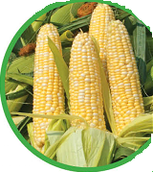
Rates and comments:
Basal fertilization is 500 kg/ha by NPK 4-9-9 before sowing. Making a deep hole, apply fertilizer, back filling by 5-7 cm of soil then sowing seeds. For winter crop, apply 415kg/ha.
Urea fertilization is needed when tree start developing leaves (3-4 leaves) (80 kg/ha). Final top dressing fertilization is required when tree has put out tender buds (300-350 kg/ha). Soil backfilling is required at each application.
Note: Hybrid maize need increasing 15-20% compared to original maize. Fertilizing outside the root area. Avoid making the roots off.
5. Multi-nutrients NPK of special for potato (2 catergories):
Category | N | P₂O₅ | K₂O | S | MgO | CaO | SiO₂ | Microelement (%)
NPK 9-9-12 | 9 | 9 | 12 | 2 | 7 | 12 | 9 | Zn, B, Cu, Co, Mn ...
NPK 22.5.11 | 22 | 5 | 11 | 2 | 5 | 9 | 8

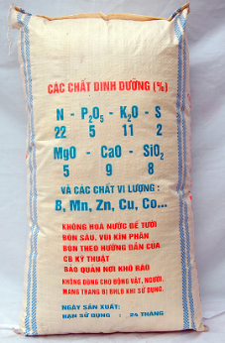
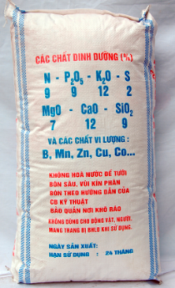
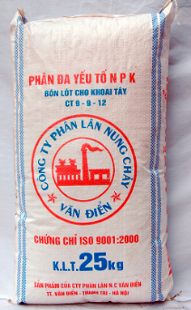
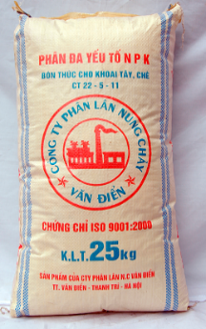

Rates and comments:
Basal fertilization is 550-700kg/ha of NPK 9-9-12 and backfilling is required before tubercles are placed. Straw or rice husk can be used as top cover.
Top dressing is provided after 25-30 days (220-350 kg/ha of NPK 22.5.11). Apply along the plant row then backfilling.
Always keep the ground moist. But keep the ground dry when potato is more than 60 days.
6. Multi-elements NPK of special use for Manioc:
Category | N | P₂O₅ | K₂O | S | MgO | CaO | SiO₂ | Microelement (%)
NPK 5-10-6 | 5 | 10 | 6 | 2 | 8 | 14 | 11 | Zn, B, Cu, Co, Mn ...

…

Rate and comment: For High-Yield Manioc (80-100 tone/ha):
Basal fertilization is dosed 610 kg /ha. Making holes, fetilizing, backfilling then place tree stump. When tree is 2 months old, top dressing is dosed 75 kg urea fertilizer plus 100 kg potassium fertilizer per ha. When manioc tree is 60-80 cm tall, another top dressing is required (280 kg multi-elements fertilizer-NPK per ha).
Note: Fertilizer must be applied 20-30 cm from tree stump.
- Multi-elements Fertilizer-NPK of special use for bean and groundnut:
Category | N | P₂O₅ | K₂O | S | MgO | CaO | SiO₂ | Microelement (%)
NPK 4-12-7 | 4 | 12 | 7 | 2 | 8 | 16 | 15 | Zn, B, Cu, Co, Mn ...

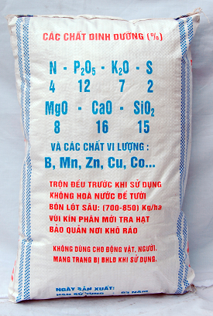
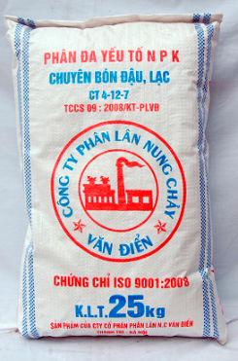

Rate and comment: 700 kg per ha is dosed for groundnut of average yield below 3.5 tone/ha; 900 –1000 kg per ha is for groundnut of average yield over 5 tone/ha.
Application: to cut a furrow deep enough to accommodate fertilizer applied. Earth backfilling is required before sowing. Average yield will be higher if applying plastic covered tecnique.
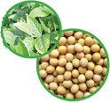
For bean and groundnut on fat land: Spread 420-560kg of lime/ha incorporation with cultivation 7 days before sowing. To cut a furrow deep enough to accommodate fertilizer (organic fertilizer plus 700-840kg of NPK 4-12-7/ha) applied. Earth backfilling is required before sowing. On large field, spread lime, organic fertilizer and 700-840kg of NPK 4-12-7/ha incorporation with cultivation 7 days before sowing.
For bean and groundnut on intercropping land (between two rice crops): After havesting, make the stump 10-20cm height, sowing to the stump row (only sowing to one of two close together rows) or spread seeding on the field or cut the furrow to sow. Then mix 420-560 kg of NPK 4-12-7/ha with 1-2 basket of powder soil and apply to the field (right after the trees have a real leaf)
- Multi-elements Fertilizer-NPK of special use for Fruit-trees ( 2 categories):
Category | N | P₂O₅ | K₂O | S | MgO | CaO | SiO₂ | Microelement (%)
NPK 2-12-4 | 2 | 12 | 4 | 2 | 8 | 16 | 13 | Zn, B, Cu, Co, Mn ...
NPK 4.10.4 | 4 | 10 | 4 | 2 | 7 | 14 | 12
Rate and comment
Basal fertilization is dosed 1,5-2 kg of NPK 2-12-4/tree. Applying on the hole, backfilling and place the nurseling on the hole.
Fertilization before or after harvesting: Using NPK 4.10.4. Dosage is based on year of growth: fertilization is dosed 1-1.5 kg per 1-3 years old tree; 2-3.5 kg per 4-6 years old tree; 4-4.5 kg per 7-10 years old tree. Fertilization is dosed 6-7.5 kg for tree over 10 years of age. Digging a trench ( 30cm wide and 30-40cm deep) around the tree root (by the leaf canopy). Filling the NPK 4.10.4 in the trench then back filling with soil.
9. Multi-elements Fertilizer-NPK of special use for sugar- cane ( 2 categories: NPK 6.12.5 for basal fertilizing and NPK 15.5.20 for top dressing)
Rate and comment (depending on expected yield of variety and the fat of land)
Basal fertilization is required before placing cuttings (600 kg NPK 6.12.5 + 70 kg potassium fertilizer)/ ha. When sugar-cane start developing tender branches, fertilization is dosed (250 kg urea fertilizer + 70 kg potassium fertilizer )/ha. When sugar-cane has developed 4-5 nodes, fertilization is dosed 600 kg multi-elements-NPK 15.5.20/ha. Fertilizer applied must be covered with earth.
10. Multi-elements Fertilizer-NPK of special use for coffee tree
Category | N | P₂O₅ | K₂O | S | MgO | CaO | SiO₂ | Microelement (%)
NPK 10-5-12 | 10 | 5 | 12 | 3 | 7 | 7 | 6 | Zn, B, Cu, Co, Mn ...
NPK 10.8.12 | 10 | 8 | 12 | 3 | 8 | 15 | 13
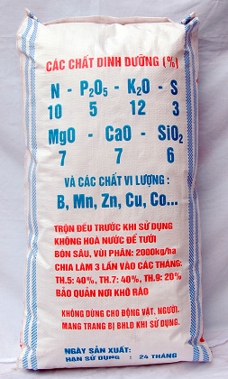
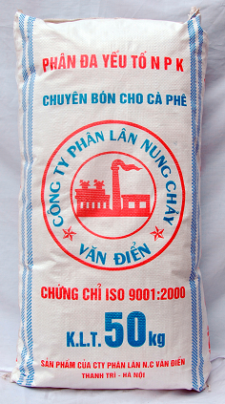
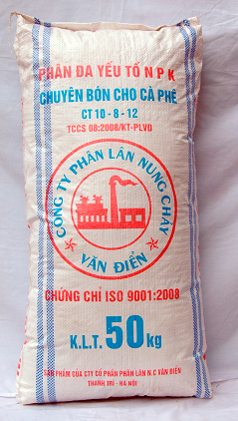
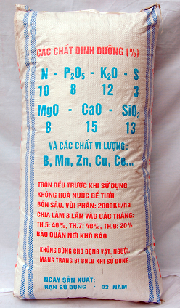

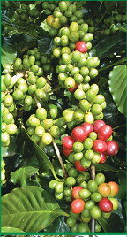
Rate and comment: apply for coffee tree is over 4 years old in every year:
The first time (January- February): apply 200kg of Ammonia Sulphat per ha
The second time (March-April) and third time (July- June): apply 600-700kg of NPK10.5.12 or NPK 10.8.12 per ha.
The fourth time (August- September): apply 150-160 kg urea per ha plus 170kg of potash per ha.
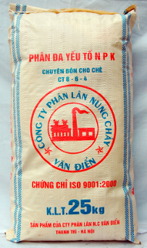
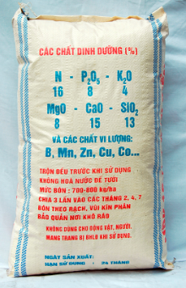
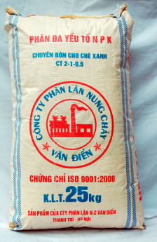
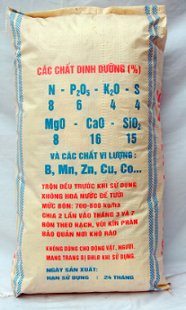
11. Multi-elements Fertilizer-NPK of special use for tea tree

There are 9 kinds of NPK for tea tree for different soil, tree age with different spending level including NPK 16-8-8; 16-8-4; 3-0,5-1; 8-6-4; 22-5-11; 25-5-11, 2-1-2; 4-1-2+5%S; 4-1,5-4.
Rate and comment : The rate is depend on the nutrients avaialbe in the soil. Dosage normally is based on 150-200 kg/tone of fresh bud. Digging trenchs (6-10cm deep) between tea tree rows. Fertilizer applied must be covered with soil. Irrigation if the soil is dry. For hill land with slope more than 15⁰, digging deeper trenchs with higher rate for trees on the top and lower rate for trees at the down of hill.

12. Multi-elements Fertilizer-NPK of special use for rubber tree (over 4 years old)
Using NPK 12.8.12
Rate and comments:
Soil type | Period to fertilization | Rates (kg/ha) | Comments
Type Ia and Ib | The beginning of rain season (March-April) | 400-450 | Spread the mixture of FMP, urea and potash on the band 1-1,5m wide between two row of trees then back filling with soil. For hill land with slope more than 15⁰, filling the mixture in nutrients-keeping hole system then back filling by soil and decayed grass.
 | The ending of rain season (August- September) | 200-250
Type IIa and IIb | The beginning of rain season (March-April) | 450-500
 | The ending of rain season (August- September) | 250-300
Type III | The beginning of rain season (March-April) | 450-500
 | The ending of rain season (August- September) | 350-400
13. Multi-elements Fertilizer-NPK of special use for Mulberry (Soil Type Based 4 categories)
Category | N | P₂O₅ | K₂O | MgO | CaO | SiO₂ | S | Na₂O | Microelement (%)
CT1: hill | 18 | 5.6 | 9 | 5 | 10 | 9 | 2 | 3 | Zn, B, Cu, Co, Mn ..
CT2: alluvial land | 17 | 7.5 | 5.5 | 6 | 12 | 10 | 2 | 3
CT3: silkworm stock | 16.6 | 7.3 | 7 | 6 | 12 | 10 | 2 | 3
CT4: saline soil | 18 | 8 | 3 | 8 | 15 | 13 | 2

Dosage: 420-560 kg /ha without the need for nitrogen or potassium fertilization.
Period of fertilization: Jan.; March; May, July and August.
Application: scratch soil 20-30 cm far from tree root, 15-20 cm deep to accommodate fertilizer. Earth backfilling is required.
14. Multi-nutrient NPK fertilizers for most crops (2 catergories)
Category | N | P₂O₅ | K₂O | S | MgO | CaO | SiO₂ | Microelement (%)
NPK 5-10-3 | 5 | 10 | 3 | 1 | 8 | 16 | 15 | Zn, B, Mo, Cu, Co ..
NPK 10-10-5 | 10 | 10 | 5 | 1 | 8 | 16 | 15
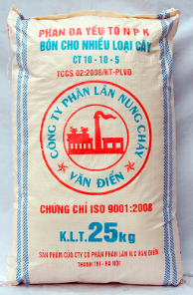
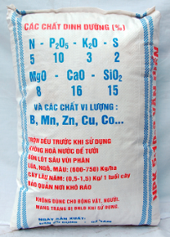
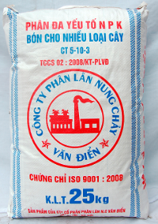
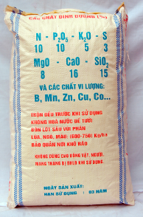

Rate and comments:
Application for rice: dosage differs from level of yield ranging between 7-8.5 tone/ha and following recommendations bellows:
+ NPK 5-10-3, : basal fertilization is 600-700 kg/ha right after field-raking.
+ NPK 10-10-5: basal fertilization (700 kg/ha) right after field-raking for the rice that have level of yield ranging between 7-10 tone/ha
Application for vegetation: dosage is according to crop average yield and can be same level or higher than it is for rice. Attention should be given to that fertilizer must be placed and covered by earth before scattering seeds. No contact between fertilizer and seed is allowed.
Application for fruit-trees: NPK 5-10-3 can be used with different dosage according to type of tree and growth period. Fertilization dosage can be between 0.5-2 kg/year of growth. Application is recommended right after harvest time. A trench is digged to be 30 cm wide. Fertilizer is scattered. Irrigation is supplied after backfilling. Fertilize time and dosage for each plant by recommendation of local agricultural scientist.
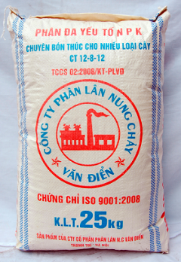
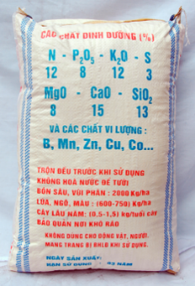
- Multi-nutrient NPK 12-8-12

Category | N | P₂O₅ | K₂O | S | MgO | CaO | SiO₂ | Microelement (%)
NPK 12-8-12 | 12 | 8 | 12 | 3 | 8 | 15 | 13 | Zn, B, Mo, Cu, Co ..
Other multi-nutrients NPK fertilizers included NPK 16.6.16; 16.16.8; 12.12.12; 20.3.20 can be applied to most crops such as: coffee tree, rubber tree, pepper tree, rice, sugar cane, pineapple. For rate and usage, please follow to the local agricultural scientists’ advices.
VANDIEN FUSED MAGNESIUM PHOSPHATE FERTILIZER J.S.C
GENERAL DIRECTOR

Van Hong Son

